Technical Reference Guide

Tie-Line Manager

from Version 2.00



OmniBus Systems

No part of this publication may be reproduced, transmitted or transcribed in any form or by any means including photocopying and recording or otherwise, without the prior permission of OmniBus Systems.

The software described in this document is furnished under a licence agreement.
The software may be used or copied only in accordance with the terms of the agreement.

OmniBus Systems
Stanford House
Stanford-On-Soar
Loughborough
Leicestershire
LE12 5PY
UK

Tel. UK : 0990 004 300 - Fax : 0990 004 333
Tel. International : +44 990 004 300 - Fax : +44 990 004 333

Hardware/Software support
Tel. UK : 0990 004 350 - Fax :0990 004 353
Tel. International : +44 990 004 350 - Fax : +44 990 004 353
e-mail : support@omnibus.co.uk

All lines are open from 10 AM to 5 PM Monday to Friday.

OmniBus Systems is a trademark of AVS Graphics Ltd.

Copyright © 1996 -2000 AVS Graphics Ltd. All rights reserved.

This document relates to the software version number stated and to no other application with the same name but different version number. As OmniBus Systems has a policy of continuous improvement to its products, the company reserves the right to change specifications without notice. Unless stated otherwise, all information in this is document proprietary to Omnibus Systems and must not be distributed to third parties without prior consent of Omnibus Systems Ltd.

Reference Guide Effectiveness Survey
In order to improve the effectiveness of our documentation, we rely upon feedback from you, our Users. Please fill in this short query form and return it to OmniBus Systems. If you prefer to respond electronically, please send an email to Docs@OmniBus.co.uk, requesting an electronic version of this form.

Each statement will be followed by five boxes, as below. Simply indicate which response is most applicable, by marking the relevant box. For any statements, which are not, in your view, followed by a suitable response, either leave the boxes blank, or write in a brief comment.

1. OmniBus Systems provide a Networked Control System.
☑ ◻ ◻ ◻ ◻
Strongly Agree Agree Unsure / Irrelevant Disagree Strongly Object
Sample statement, showing response options.

1. The documentation supplied was useful in day-to-day operation of the system.
◻ ◻ ◻ ◻ ◻
Strongly Agree Agree Unsure / Irrelevant Disagree Strongly Object

2. The documentation was clearly and logically structured and presented.
◻ ◻ ◻ ◻ ◻
Strongly Agree Agree Unsure / Irrelevant Disagree Strongly Object

3. The system requires more documentation.
◻ ◻ ◻ ◻ ◻
Strongly Agree Agree Unsure / Irrelevant Disagree Strongly Object

4. The documentation was pitched at the correct level of User aptitude.
◻ ◻ ◻ ◻ ◻
Strongly Agree Agree Unsure / Irrelevant Disagree Strongly Object

5. It is valuable having a Guide to refer to.
◻ ◻ ◻ ◻ ◻
Strongly Agree Agree Unsure / Irrelevant Disagree Strongly Object

6. The documentation helps me do what I need to do.
◻ ◻ ◻ ◻ ◻
Strongly Agree Agree Unsure / Irrelevant Disagree Strongly Object

7. The documentation answers my queries regarding the software.
◻ ◻ ◻ ◻ ◻
Strongly Agree Agree Unsure / Irrelevant Disagree Strongly Object

8. I am more confident having a Guide available.
◻ ◻ ◻ ◻ ◻
Strongly Agree Agree Unsure / Irrelevant Disagree Strongly Object

9. It would be useful having additional Guides for more experienced Users.
◻ ◻ ◻ ◻ ◻
Strongly Agree Agree Unsure / Irrelevant Disagree Strongly Object

Thank you for your co-operation. Please return this query form to:

Testing and Documentation
OmniBus Systems
Stanford House
Stanford-On-Soar
Loughborough
Leicestershire
LE12 5PY
UK

Tel. UK : 0990 004 300 - Fax : 0990 004 333
Tel. International : +44 990 004 300 - Fax : +44 990 004 333
Email : Docs@OmniBus.co.uk

Contents

Tie-Line Manager i
Reference Guide Effectiveness Survey iii
Tie-Line Manager 6
About this Manual 6
1) Introduction to the Tie-Line Manager 6
2) Tie-Line Properties and Limitations 8
3) Outline of Routing using Tie-Lines 9
4) Tie-Line Manager Program Structure 10
4.1) Program Threading Structure 10
4.2) Starting the Omnibus Application 11
4.3) Opening the Omnibus Service 11
4.4) OmnService Callbacks 12
5) Tie-Line Manager Databases 16
5.1) Local Caching 16
5.2) Tie-Line Manager Application Configuration 16
5.3) Tie-Line Database 16
5.4) Tie-Line Blocking Rules List 18
6) The Routing process in the Tie-Line Manager 19
6.1) Outline of the Functions used in the Tie-Line Routing process 19
6.2) Finding a Route using hops and walking along the Tie-Lines 21
6.3) Issuing Routing Commands 22
6.4) Tie-Line Manager Level Matching 23
7) Source Blocking 24
8) The Tie-Line Manager OUI 25
8.1) Creating a New Tie-Line 25
8.2) Tie-Line Configuration 25
9) Logging within the Tie-Line Manager Application 26
10) Routing and Tie-Line Manager Glossary 27

Tie-Line Manager

About this Manual
This document assumes a prior knowledge of the OmniBus routing system and experience of programming in C using the OmniBus libraries. Reading pre-requisites are the Router Control Application Notes and help guides and the Routing Client libraries SDK. If you have not already done so, you should read these now.
We have produced this guide to the Router 3 source code to provide details of information flow, program structure and the techniques used within the application. After studying the maual you should have an understanding of how the router works be able to maintain and develop the code.

1) Introduction to the Tie-Line Manager
A Tie-Line is a connection from a Destination of Router Matrix to a Source of a Router Matrix. Commonly the Matrix Destination is in one area and the Matrix Source is in another area, but they can be in the same area and are then called Local Tie-Lines. Tie-Lines can also incorporate level converters, eg. PAL to SDV.
The Tie-Line Manager (TLM) application does not control routing matrices directly, and so has no serial outputs. It receives routing requests over the network from Router Controllers which cannot handle their own routing request, usually due to the source being outside their area. The Tie-Line Manager checks the requested route and if possible and legitimate it issues the appropriate commands over the network to the required Router Controllers to make the route.
Only a single Tie-Line Manager, or Master/Mirror pair, is allowed in each Domain to service all Router Controller Device Applications in that Domain.

Sources & Destinations are often designated numerically by Router Controllers and Tie-Line Managers in a 32-bit format which includes the area and an index:
Area No. : Local Index (16 bits : 16 bits)

The Area No. is unique for each Router Controller within a Domain.
The Local Index is the index into the local static database of Sources or Destinations (one for each) held by the Router Controller.

A typical inter-area Tie-Line is shown below:

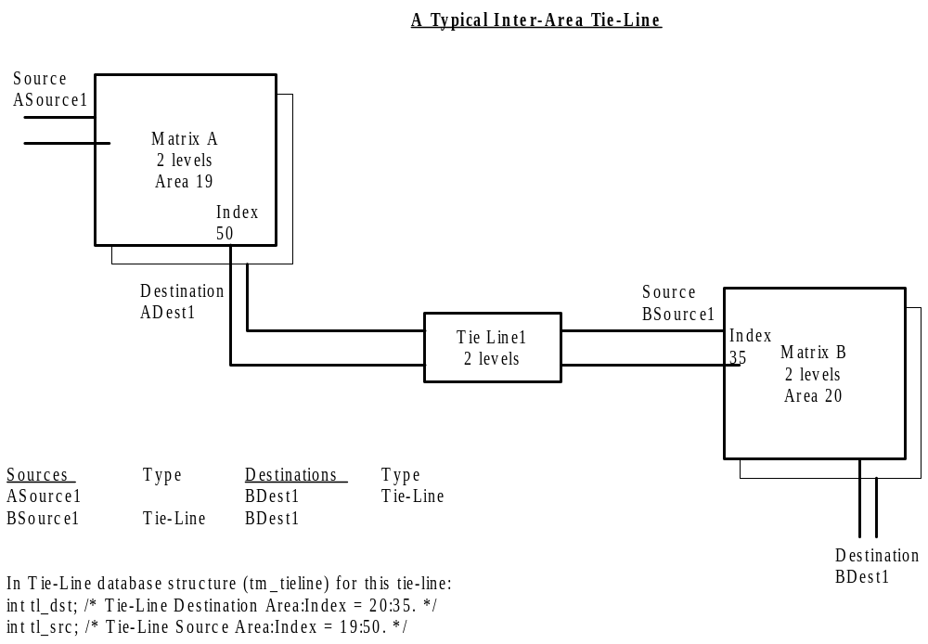

2) Tie-Line Properties and Limitations

- Tie-Line Sources are router destinations.
- Tie-Line Destinations are router sources.
- Tie-Lines can have only one source and one destination (Only one entry in Router Database at either end, and all source ends are routed always).
- Tie-Lines are configured to be single or multi-level, as necessary, and are used fully with no options to partially use Tie-Lines.
- A married destination cannot use multiple single level tie lines to make a hop.
- The Source of a matrix must support all levels of the destination.
- Local Tie-Lines can link the matrices of one Router Controller, but are still managed by the Tie-Line Manager.
- Each Tie-Line is configured to be one of the following:
- Floating – The Tie-Line is useable by all, and are used and released as necessary. Tie-Lines are released when all Destination users of the Tie-Line route to a different Source.
- Reserved – The Tie-Line is allocated for use by the specified Destination. The Tie Line logic will not use this Tie Line unless the destination requesting the Tie Line matches the configured destination. The system option “Share Reserved” allows a different user to use this Tie-Line if he requires the same souce as the reserved user. However, the reserved user has full rights to move the Tie Line source unconditionally.
- Fixed – The Source of the Tie-Line is permanently fixed to that specified. If a destination requires a particular source, fixed Tie Lines are used in preference to floating ones, as they are guarenteed to remain routed to that source.
- Over all operation of Tie-Lines can be configured to have:
- Polite Sharing – If ON, then all users of a Tie-Line are considered equal. Each Tie-Line will not be released from use until all its users have gone. Therefore a desination, having acquired a remote source, would never lose that source. If OFF then the first User is the Owner, and if it releases the Tie-Line then all other users will be disconnected.
Polite Sharing and TLM-2 – Polite Sharing is ON permanently in TLM-2. There is no option for switching it off.
- Share Reserved – Share a Reserved Tie-Line if it has the required Source.
- Park Ties on Release – A source for each physical matrix may be configured as its park source. When “Park Ties on Release” is set the router controller routes the levels of the destination that the Tie-Line’s source is connected to the park source.
- Auto Ownership – If Auto Ownership is enabled, then when the Tie-Line Manager receives from the network a route which has happened which uses a Tie-Line, it adds the destination as a user to the Tie-Line.

3) Outline of Routing using Tie-Lines
The basic sequence of events when a client requests a route which involves a Tie-Line is as follows:

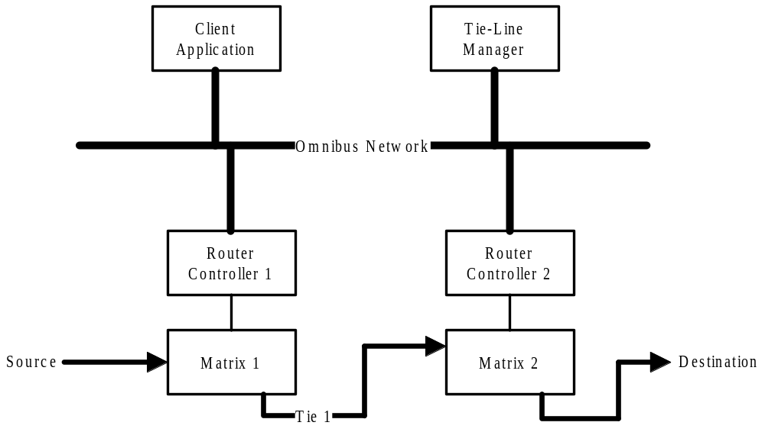

- The Client Application requests a route from Source to Destination.
- The Router Library (part of the Client Application) sends the request to Router Controller 2, since this has the Destination.
- Router Controller 2 cannot make the route since the Source and Destination belong to different Router Controllers, so it forwards the request to the Tie-Line Manager.
- The Tie-Line Manager finds that Tie-Line 1 has the required connection, provides the required levels, is available and the Source is not blocked from connecting to the Destination. So it sends a request to Router Controller 1 to route the Source to Tie 1, and a request to Router Controller 2 to route Tie 1 to the Destination.
- Router Controller 1 carries out its route request and broadcasts an update.
- The Router Library in the Client Application (and in other applications) receives the update and informs the Client that the current destination of Tie 1 source (on Router Controller 2) is routed to the Source.
- Router Controller 2 carries out its route request and broadcasts an update.
- The Router Library in the Client Application (and in other applications) receives the update and informs the Client that the Destination is routed to the Source.

4) Tie-Line Manager Program Structure

4.1) Program Threading Structure
The threading structure of the Tie-Line Manager is very simple, see diagram below. Much of the routing house-keeping is performed by the Routing Library which is linked into the application.

At start up the Foreground Thread’s main tasks are to start the Application, open the Router Library, start the omn service, and load its database. When completed it just sits waiting for any input from the engine’s keyboard.

The Handler functions deal with requests to the Tie-Line Manager from the omnibus network.

The Housekeeping Thread is a low priority thread, so that it does not heavily load the processor, which deals with updating the Tie-Line Status screen. The status screen needs to be updated whenever the Tie-Line Manager receives information, through the handler routehapnd(), that a Tie-Line’s users have changed. Since several broadcasts may be received in quick succession and the full data for the status screen has to be sent, the Housekeeping Thread restricts status screen updates to no more than one a second.

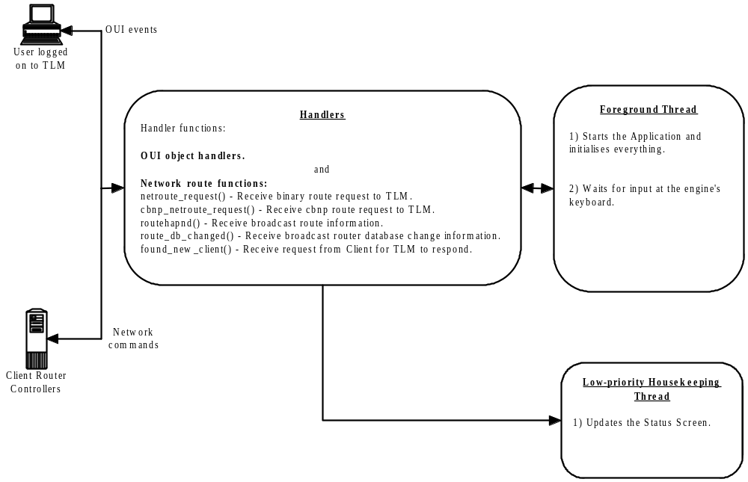

4.2) Starting the Omnibus Application
The OmniBus Application is started, with the necessary resources allocated and threads set up, using the function call:

eError = omnibus_open( &hApp, /* Application Handle. */
"Tlm", /* Application Name. */
"", /* Default Resource Path. */
VERSION, /* Version Number. */
0, /* Default Logon Icon. */
OMNIBUS_ACTIVATE_LATER); /* Activate Later. */

It is flagged to be activated later to allow handlers to be set up before the application is announced to the network.

4.3) Opening the Omnibus Service
The Omn-Service is opened using this function call:

omnsvc_open(&hOmn, OMNSVC_TLMGR, OMNSVC_SERVER, hApp);

Where:

hOmn is an unintialized omn-service handle

OMNSVC_TLMGR is the service type

OMNSVC_SERVER specifies that this application is a server of this service

hApp is the Router Controllers Application handle.

4.4) OmnService Callbacks

To listen for commands from clients on the network, four callback functions are registered which will be triggered when the appropriate network message is received:

Finding a New Client

When a client comes online it sends a broadcast on the network asking for the Tie-Line Manager to announce its availability. The call-back that is triggered for this event is registered using this function call:

omnsvc_find_svc_reply(hOmn,found_new_client,0);

Where found_new_client() is the call-back function:

ERROR_CODE found_new_client
(
int iArea,
int iUser,
int iSvcFlags,
int iSvcSpecific,
sockad *ptrFrom,
int iParameter
);

When this call-back function is triggered it sends the location area of the Tie-Line Manager.
The only function parameter that gets used is sockad *ptrFrom, which contains the network address of the client requesting the service.

Receiving Router database changes broadcast over the network

The call-back route_db_changed() is triggered when the application receives Router database changes broadcast over the network. This call-back is registered by using the function:

route_startup(&RouteHandle, routehapnd, route_db_changed, NULL, hApp, NO_FLAGS);

The function prototype for this call-back function is:

ERROR_CODE route_db_changed(
int iArea, /* Not used. */
int iPart, /* Not used. */
int iMissing, /* Contains which bits of the database are still required for a complete database – only
proceed when this is zero. */
ROUTE_HANDLE RouteHandle) /* Not used. */

If iMissing is not zero then the function returns immediately. Only when it is zero, indicating that all the database has been loaded, does the function do anything.
The function then:
- Refreshes the tie-line database from the network.
- Updates screen items.
- Updates the Tie-Line Edit Data List.
Note that the function is triggered at start up as soon as Routelibs is activated by open_routelib(),and then whenever a router change is broadcast.

Receiving a CBNP Router Command message

This call-back is triggered when the application receives a CBNP router message.
This message may be either a router status message broadcast from another router or it may be a route command message sent from a client. Client’s broadcast their route commands so this message may not be intended for this router. Also there is no distinction between a CBNP salvo and a CBNP single route command (a CBNP single route command is actually a CBNP salvo containing 1 route).

This call-back is registered by using the function:

omnsvc_receive_data(hOmn, data_cbnp, cbnp_netroute_request,0);

where data_cbnp is defined in the omnibus libraries as a CBNP message type.

The function prototype for the call-back function is:

ERROR_CODE cbnp_netroute_request
(
int iArea,
int iUser,
int iDataSize,
void *ptrData,
sockad *FromAddr,
int iParameter
);

The only parameters used in this function are:

sockad *FromAddr – this contains the network address of the client which sent the message
(the IP address is also specified in the CBNP message header, but it is quicker to use the sockad in its raw form and it cannot be so easily tampered with.)

void *ptrData – contains a pointer to the CBNP message

int iDataSize - contains the size of this message in bytes.

When the call-back is triggered it attempts to decode the CBNP message into a salvo structure which it can process.

The CBNP message header will also contain additional information: the client application name, a client application defined integer and string. All these details plus the clients network address must be passed through the router application and appear in router status updates. This is done in the form of a ROUTE_REQ_INFO structure which is attached to all routing commands and will be explained further on in this document.

If decoding is a success the Tie-Line Manager will attempt to process the routing requests of the salvo via tlm_route() and tl_make_path_between_endpoints(). It issues its own routing requests to router controllers using the cbnp function route_text_command().

For backwards compatibility there are two other methods of receiving route commands that were implemented in Router Controller Version 1:

Call back for non-CBNP route commands

This call-back is registered by using the function:

omnsvc_receive_command(hOmn,report_connectedto,netroute_request,0);

where report_connectedto is defined in the omnibus libraries as a single route command consisting of four parameters.

The function prototype for this call-back function is:

ERROR_CODE netroute_request
(
int num,
int logic_in,
int logic_out,
int lvls,
sockad *ptrFromAddr,
int iParameter
);

The four parameters represent:

int num = Mode

int logic_in = 32 bit global router source index

int logic_out= 32 bit global router destination index

int lvls = router levels, in bit field format

This function process the routing request, via tlm_route() and tl_make_path_between_endpoints(). It issues its own routing requests to router controllers using the cbnp function route_text_command().

Call back receiving routing information

When a routing event happens the router controller must broadcast the status information to the network so that routing clients can keep their internal copy of the router status map up to date. This is done by sending a CBNP router status message to the Networks' broadcast address.

The Tie-Line Manager call-back routehapnd() receives these broadcasts. The call-back is registered by the function:

route_startup( &RouteHandle, routehapnd,route_db_changed,NULL, hApp, NO_FLAGS);

The function prototype for this call-back function is:

ERROR_CODE routehapnd
( UINT lvls, /* Router levels, in bit field format. */
int dst,
int src,
int flags,
UCHAR dynamic_attribute_flags, /* Not used. */
ROUTE_REQ_INFO RouteReqInfo, /* Not used. */
ROUTE_HANDLE RouteHandle /* Not used. */
)

This function processes the routing information received from the network:
- Frees Tie-Lines that are no longer used.
- Updates the Tie-Line Status Screen if it is showing on the OUI.
- If Auto-Ownership is on, updates the users of a Tie-Line if the routing information indicates that a destination is using a Tie-Line.

5) Tie-Line Manager Databases
Each Router Controller keeps its own database of sources, destinations, and a status map (which source each destination is connected to), creating a logical common view of the physical matrices connected to it.

The function load_and_setup() is called during start up and loads the databases needed.

5.1) Local Caching
Copies of the Tie-Line Manager Database files (see below) are also stored on the local hard-disk so the Tie-Line Manager can still be used if the Sharer cannot be found.

At start up, if the Sharer can be found then the database files are loaded from it. If the Sharer cannot be found then the database files are loaded from the local hard disk.
When any of these databases is saved to the Sharer then it is also saved to the local hard disk. If the Sharer cannot be found then the database will not be saved at all, since the copy on the Sharer and the local copy must be identical.

5.2) Tie-Line Manager Application Configuration
The Configuration of the Tie-Line Manager Application is loaded file TLM_CFG on the Sharer.
If the Sharer cannot be found then it loads from a local copy of the file on the engine’s hard disk.
When the configuration is saved, using the OUI, copies are saved both on the Sharer and the local hard disk.

5.3) Tie-Line Database
The Tie-Line Database file is loaded from the file TLM_DB on the Sharer. This is used to generate a linked list of Tie-Lines, stored in Ascending order of Tieline Destination Area. The head of the linked list is stored in the listhead structure tielines.
If the Sharer cannot be found then it loads from a local copy of the file on the engine’s hard disk.
When the Tie-Line Database is saved, using the OUI, copies are saved both on the Sharer and the local hard disk.

The handler route_db_changed() receives router changes broadcast over the network, through Routelib, so that the Tie-Line database can be kept up to date. It is triggered at startup as soon as Routelibs is started, and then whenever a router change is broadcast.
This handler function calls db_refresh() which scans for sources which are Tie-Lines and extracts their Ids and makes sure that the Tie-Lines are in the database. It then scans for destinations with matching Ids and updates its database accordingly.
Pressing the “Refresh” button in the Status screen of the OUI manually initiates the same processes as route_db_changed() if desired though is not necessary.

During start up the function initialise_tl_usage() is called to update the Tie-Line Database with the usage of the Tie-Lines. This uses Routelibs functions to obtain from the Sharer the database of Destinations and sorts out the Tie-Lines and the matrices that they connect. It stores them in its Tie-Line database, and inserts the details as Tie-Line Source information.
It then reads the database of Sources, sorts out the Tie-Lines, and using their names matches each with its Tie-Line entry and inserts the destination information in its Tie-Line database.
The Source and Destination databases are then searched again to find Tie-Lines which are already in use, and the Tie-Line database is updated accordingly.
The Tie-Line usage is automatically updated by the handler route_db_changed() which receives broadcast database changes.

/* Structure for the data of each tie-line - These are arranged in a linked list. */
typedef struct
{
struct list item; /* Linked list management details. */
tl_stat stat; /* Not used. */
int tl_spare;
char ref[RT_IDT_LEN]; /* The long name for the tie-line. */
int tl_dst; /* TIE-LINE DESTINATION area:index (16-bits:16-bits) = ROUTER SOURCE. */
int tl_src; /* TIE-LINE SOURCE area:index (16-bits:16-bits) = ROUTER DESTINATION. */
int lvls; /* Levels suported. */
struct listhead tl_users; /* Head of a linked list of the destinations using this tie line. */
char name[24]; /* Tie-Line name. */
int fixd_src; /* The source if the tie line has a fixed source. -1 if not. */
int resv_dst; /* The destination if the tie-line is reserved. */
int spare[3];
char type; /* TL_TYPE_FLOAT/TL_TYPE_FIXED/TL_TYPE_RESRV. */
char cspare[3];
tl_flags flags; /* Flags – only one is used, tl_on (True -> Tie-line on-line. False -> Tie-line off-line). */
}

/* Structure for users of a Tie-line. */
typedef struct
{
struct list item; /* Linked list management details. */
int tl_user; /* The User (the ultimate destination of the tie-line). */
time_t time_in; /* Record time user aquired tie line. */
unsigned int lvls; /* Levels used by this user. */. */
int spare[4];
};

5.4) Tie-Line Blocking Rules List
Blocking Rules are used to block Sources from being connected to certain Destinations. The Tie-Line Blocking Rules List is loaded from the file TL_BLOCK on the Sharer.
If the Sharer cannot be found then it loads from a local copy of the file on the engine’s hard disk.
When the Tie-Line Blocking Rules List is saved, using the OUI, copies are saved both on the Sharer and the local hard disk.

The structure of each Source in the Blocking Rule List. This list is kept in order of ascending source.
typedef
{
List blocks; /* All the srcs known by this list */
int src; /* An individual router src */
int default_rule; /* Default Allowed/Disallowed to ALL Dsts */
Listhead rules_list_head; /* The head of the linked list of rules for this source. */
} block_list;

The structure of each Blocking Rule in the Blocking Rule List. This list is kept in order of rule significance.
/* Areas / Dests (Rules) are kept in ascending order */
typedef
{
List rules;
int rule;
int flags;
} block_rules;

6) The Routing process in the Tie-Line Manager

6.1) Outline of the Functions used in the Tie-Line Routing process
In the Tie-Line Manager netroute_request() and cbnp_netroute_request() (in tm_netwk.c) handle binary and cbnp routing requests from the network, respectively.
These call src_allowed_to_dst() to check for any Block Rules between the source and destination, and if OK call tlm_route() (in tm_route.c).
Function tlm_route() calls tl_find_path_between() (in tm_dbase.c):
The function tl_find_path_between() calls tl_find_tieforareas() to find any direct tie-line between the source and destination areas.
If not then it tries to navigate through by walking along ties.
If a path is found it then tlm_route() calls tl_make_path_between_endpoints() which sends the routing commands in cbnp format using route_text_command().

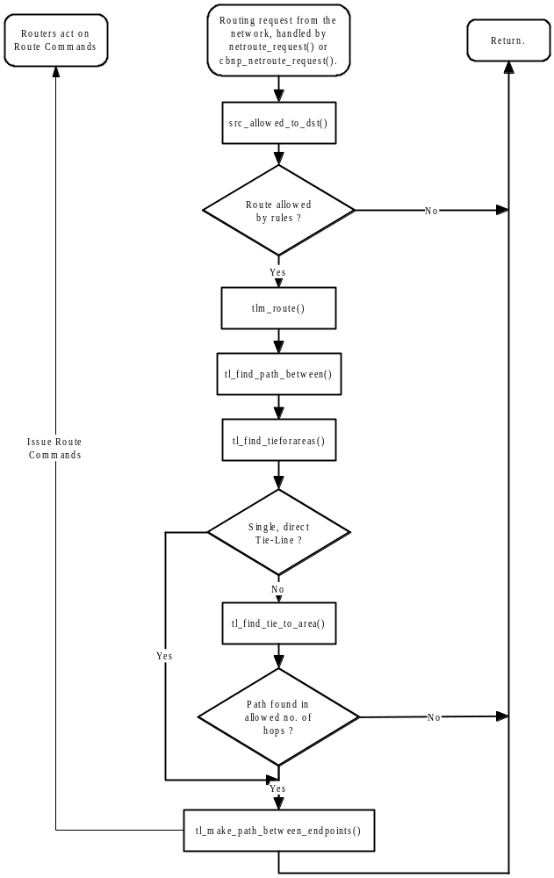

The handler for the OUI “Find Path” and “Make Path” buttons is h_tl_route(). “Find Path” allows a check on a route without actually making it.

6.2) Finding a Route using hops and walking along the Tie-Lines
The strategy used by the function tl_find_path_between() to find a route when there is no direct Tie-Line is to walk forwards and backwards along the tie lines from the destination area till it finds the source area, or not.
EXAMPLE: Consider the situation below with 8 router areas, each with its own router controller. These are joined by the Tie Lines shown:

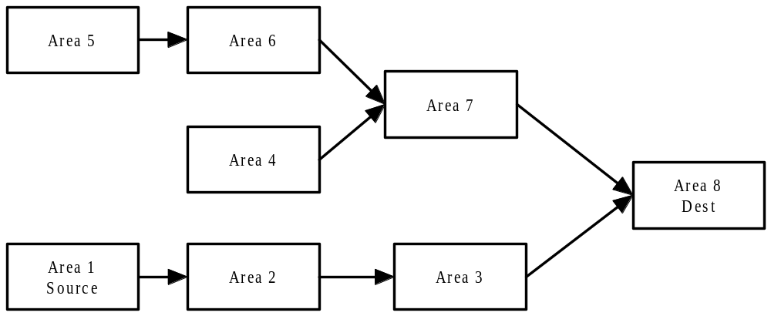

To route from a Source in Area 1 to Destination in Area 8 we start at the destination and look for a suitable direct tie-line to the source. If there is a direct tie-line then use it.

In this case there is no direct tie-line, so it checks for a suitable direct tie-line to the source from areas one hop from the destination. In this case Areas 3 and 7 are one hop from the destination, so it looks for any direct tie-lines joining Area 7 or Area 3 to the Source (Area 1), but does not find any.

It then continues at 2 hops from the destination, and so on, checking for direct tie-lines to the source area. This process continues until it (A) Successfully finds a route (B) Reaches the maximum number of hops allowed without finding a route (C) Cannot find a route.

In this case it will find that the there is a direct tie-line between Area 2 and the Source and so can use the route Area 1 to Area 2 to Area 3 to Area 8.

At each stage it checks whether it is permissible to use a tie-line by checking that the required levels are available and that the tie-line is available with the required mode (Polite, Exclusive, Shared/Reserved).

The program is very inefficient when there are tie-lines in both directions between two areas. In the case below a tie-line is required to route the source Area 1 to the destination Area 4.
The function tl_find_path_between() will check for a direct tie-line between the source area of Tie 2-3-1 (that is Area 2) and the source (Area 1). There is not one, so it will then check for a direct tie-line between the source area of Tie 2-3-2 (again Area 2) and the source, and again it will not find one. It will repeat this for Tie 2-3-3 and Tie 2-3-4, again with negative results.

Then it will go to the next stage and look for a direct tie-line between the source area of any tie-line connected to the sources of the immediate ties. So starting with the source of Tie 2-3-1 which is Area 2, it checks for a direct tie-line from the source of any of its tie-lines. In this case it will check for a direct tie-line from Area 3, the source of Tie 3-2-1, to Area 1. It will then perform this check again via Tie 2-3-2, and again via Tie 2-3-3, and yet again via Tie 2-3-4.

This carries on in pyramid selling fashion around this loop until the maximum number of hops is reached when it aborts.
To minimise this the operator selectable variable “Max Hops” should be set low.

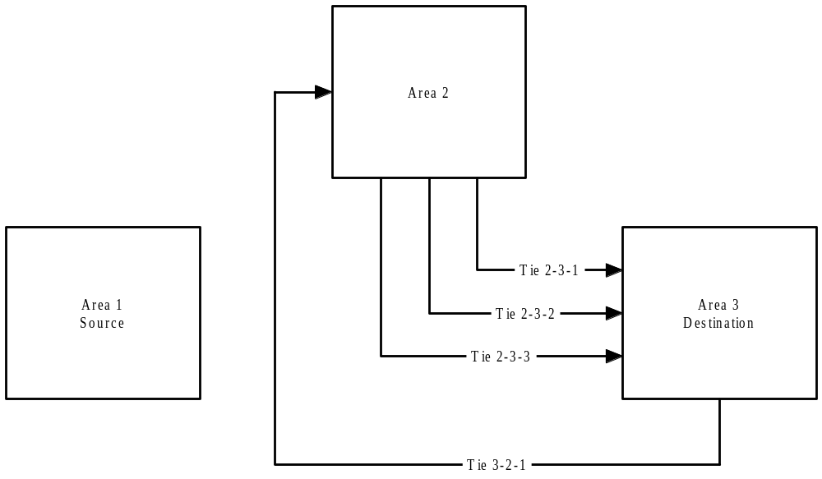

6.3) Issuing Routing Commands
The Tie-Line Manager issues routing commands to Router Controllers using the routelibs cbnp function route_text_command(). The intermdiate tie-lines are routed first, then the source, and finally the destination.

6.4) Tie-Line Manager Level Matching

Notes on Inter-level routing:
- Router Controllers can perform Inter-level routing at the matrix level if the matrix supports it. It is used for routing from one level to another when the signals of the levels are in the same format, eg. for routing a single mono audio level to stereo left/right levels.
- Only the CBNP format supports inter-level routing commands to the Router Controller. It does this using a structure which incorporates information about the levels which are to be routed to each other.
- The Tie-Line Manager naturally supports routes between different levels, which are achieved by incorporating format converters in the Tie-Lines, eg. to convert from PAL to SDI.
- Both Binary and CBNP format commands to theTie-Line Manager support routes between different levels via format converters.
- There is some code in place in the Tie-Line Manager Application to support CBNP format commands incorporating information about the levels which are to be routed to each other. However, this is not fully implemented.

A Tie-Line can provide inter-level routing provided:
- The Tie-Line destination provides all the levels required by the destination of the area to which it is routed.
- The source of the area from which it is routed provides all the levels required by the Tie-Line source.

Note:
- Breakaways require separate Tie Lines.
- A married destination cannot use multiple single level tie lines to make a hop.

tlm_route(): fields the routing request:
int tlm_route
( int logic_in, /* Source. */
int logic_out, /* Dest. */
int lvls, /* Required levels. */
int mode, /* The mode requested (Polite, Exclusive, Shared/Reserved). */
route_salvo_struct *ptrRouteReq) /* Pointer to salvo (for Interlevel routing). */

The routing requests received by the Tie-Line Manager from the network include the desired levels to be routed.
“Mode” is purely a concept internal to the TLM.
tlm_route() is passed the levels received and mode flags of 0.
It masks in the mode flags as set in gbl_cfg->sysmode.
It then calls tl_find_path_between().

tl_find_path_between():
t_lvls=rt_provided_lvl_mask(rt_dst, rt_src, rt_lvls);

The Destination will support certain levels. The Source will support certain levels. The TLM has to reconcile these.

The “new” method of matching levels considers the medium type as well as the pure level matching. If medium types match then the route is allowed.
In other words, the source may not be able to provide the exact levels, but it can supply an equivalent which will be OK via a Tie-Line with a level converter.
For example, consider a PAL source and an SDI destination, which have levels of 1 and 2, respectively. A crude look would say that the level match required is 3. The new method considers that the SDI destination requires matching levels of 1, and since the PAL source is of the same medium type then it can match the level of 1 (if there is a Tie-Line with a level converter, which will be determined during subsequent checking of Tie-Lines).

A Tie-Line is a “potential” Tie-Line between two areas if the levels of its destination marry the levels of the destination area’s destination. It can be used if the source can provide all the levels provided by the Tie-Line’s source.

The function which sends the actual routing commands is tl_make_path_between_endpoints():

ERROR_CODE tl_make_path_between_endpoints(
int tl_rtdst, /* Source. */
int tl_rtsrc, /* Dest. */
unsigned int rt_lvls, /* Required levels. */
tm_tieline *tl_list[], /* List of tie-lines to be used. */
route_salvo_struct *ptrRouteReq)

The routing sequence is:
- Route together all the Tie-Lines to each other.
- Route the Source to the Tie-Lines.
- Route the Destination to the Tie-Lines.

7) Source Blocking
Every source in the system can have Blocking Rules applied. A block prevents a source being routed to certain destinations.
A new source block is added to the linked list of blocks using the “Src Blocks” menu. The default block is to disallow all routing from the source. Additional rules can be added to block routing to specific areas or specific destinations.
Each block structure in the linked list of blocks has a pointer to a linked list of rules for that block.

Note: Source blocking only applies to Network route requests and NOT Tie-Line Routes made in the TLM Route Screen directly. Source Blocks come into effect on the next route request, and existing Destinations that are already routed to a now blocked source will not be routed away.

8) The Tie-Line Manager OUI
This component provides the interface for configuration and control of the Router Controller by logging into the application from an Omnibus Workstation. Its coding will not be covered in this document, as most is fairly trivial.

8.1) Creating a New Tie-Line
A new Tie-Line is firstly configured on the Router Controller OUIs of the areas of its source and destinations. The Tie-Line Source configuration is set by configuring a Destination on the Router Controller of the Source Area to be a Tie-Line. Similarly, the Tie-Line Destination configuration is set by configuring a Source on the Router Controller of the Destination Area to be a Tie-Line, with the same name.
When the Router Controllers “Commit Changes” to the Network the Tie-Line Manager receives the broadcasts and adds the Tie-Line to its database in memory.
All Tie-Lines received via a broadcast and not loaded from the Tie-Line Manager’s own database file (TM_DBASE) are initially set to “Offline” and must be manually put online using the “Tie Config” screen of the OUI.
The database should then be saved otherwise the new Tie-Line won’t be in the database file to be loaded when the application restarts. It will still be received when the TLM asks the routers to broadcast their configurations, but will again be set to “Offline”.

Pressing the “Remove Tieline” menu button just removes the Tie-Line from the database in memory. It will appear again if the routers re-broadcast their configurations.

8.2) Tie-Line Configuration
On the “Tie Config” screen a Tie-Line can be selected as “Offline” which makes it unavailable for the Tie-line manager.
New Tie-Lines received over the network are initially flagged as Offline and this field must be selected so they are put Online before they can be used. Also they must be saved in the Tie-Line Manager’s database so that they are read at the next start up.

A new Tie-Line defaults to the type “Floating” which means that it is useable by all, and is used and released as necessary.
The type can be changed to “Reserved” or “Fixed”.

When a Tie-Line is “Reserved” it is allocated to the destination specified in the “Type Parameter” field. The Tie-Line logic will not use this Tie-Line unless the destination requesting the Tie-Line matches the configured destination. The system option “Share Reserved” allows a different user to use this Tie-Line if he requires the same souce as the reserved user. However, the reserved user has full rights to move the Tie-Line source unconditionally.

When a Tie-Line is “Fixed” the Source of the Tie-Line is permanently fixed to that specified in the “Type Parameter” field. If a destination requires a particular source, fixed Tie Lines are used in preference to floating ones, as they are guarenteed to remain static.

9) Logging within the Tie-Line Manager Application
The Tie-Line Manager produces three types of logs.
- A Standard Log written to the file named LDay_nn (where nn is the day of the month), in the folder tlm_logs on the local hard disk. The operator has no control over this and logging cannot be turned off. Information is recorded under the headings - Action, Time, Tie Line, Dst User, Source, Users, Used Since, Used For.
- A Techical Log written to the file named TDay_nn (where nn is the day of the month), in the folder tlm_logs on the local hard disk. The operator has no control over this and logging cannot be turned off. This log records TL requests and which TLs the TLM is going to use to satisfy the request including mode (Exclusive, Shared etc.).
- A Debugging Log written to the file named Day_nn.txt (where nn is the day of the month), in the folder tlm_logs on the local hard disk. This records debugging information originating from the function debugf(). Three levels of detail are used – TLM_DBG_ERROR, TLM_DBG_REPORT, and TLM_DBG_DETAIL – and the operator can select the level recorded using the Config screen. Debug logging can be directed to the log file, to the screen, or neither (ie. logging turned off), as selected.

10) Routing and Tie-Line Manager Glossary

Aliases
Two types of aliases are used by the routing client library. These are UMD source aliases and Area Aliases.

UMD source aliases are alternative names for router sources. UMD aliases are dynamic, i.e. they are likely to change throughout runtime whereas router source names are not intended to change unless reconfigured.

Area Alias names provide an alternative to the Area:Index number. Because there is no requirement for router source and destination names to be unique across areas, using area aliases is a good way of identifying which area the source/destination came from.

For example:
source 1: CAR:VTR1
source 2: TX:VTR1
Both sources are called VTR1 but can be identified by the area alias prefixed to the name.

Exclusive
This means that the Tie Line is/would be used exclusively by the specified destination.

Shared
Two or more destinations may share a source.

Married
When more than one levels are routed between the source and destination they are said to be married.

Breakaways
Each married Destination may be broken away. For example, the Video signal can be routed to one Source, and the Audio signal to a different Source.

Global X
Relates to all of the Sources on the Omnibus Network.

Global Y
Relates to all of the Sources on the Omnibus Network.

Hard parking
The routing of a Destination to a default cross-point, configured at the Router Control Device Application on a “per matrix level”. Each matrix is configured to have a park source. A park command will generate normal route commands with the source as the park. The Omnibus Network routing protocol will check for the park source in a route command. It will then send a park command instead of a route. This is typically used when releasing a Tie-line used by a Destination.

Internal Tie Lines
Tie lines between the matrices of a single Router Controller (ie. within the same area).

Make Exclusive Path
Tries to make a totally exclusive path for the selected Source/Destination.

Polite Sharing.
Does not release a Tie Line segment from use until all users of the segment have gone. Therefore a destination, having acquired a remote source, would never lose that source.

Rules (Blocking Rules)
Tie-Line Manager rules applied to prevent certain sources from being routed to certain destinations.

Tie-Line Types.
Reserved – This type of Tie-Line is allocated to a particular Router Controller destination. The Tie Line logic will not use this Tie Line unless the destination requesting the Tie Line matches the configured destination.
A system option allows a different user to use this Tie Line if he requires the same souce as the reserved user. However, the reserved user has full rights to move the Tie Line source unconditionally.

Fixed – Fixed Tie Lines supply the configured source to a particular destination area. If a destination requires a particular source, fixed Tie Lines are used in preference to floating ones, as they are guarenteed to remain static.

Floating – Floating Tie Lines form the majority of Tie Lines in the system. These are for use by all and are used and released as necessary. Tie-Lines are released when all Destination users of the Tie-Line route to a different Source.

Ultimate Source
The ultimate router source routed to the destination is the source at the end of all the tie-line hops.

Virtual Cross-Point
Software is used to calculate a route that, if actually connected, would need two or more cross-points. This is a Virtual Cross-Point and is a way of increasing the size of a switching matrix by up to 100 ‘extra’ cross-points.
One Virtual route command can generate a large number of real route commands. Posting a thread message is relatively slow compared to a normal function call. For this reason, the virtual route command is posted to the PortProc thread, which will generate the real route commands. This gives complex virtual routes a significant increase in speed.
NOTE: When switched, the virtual crosspoints details are broadcast, not the actual physical cross points used.

